1. A line plot showing the trend of temperature in a given city

2. City with maximum rainfall

3. City with minimum rainfall In attachment is the data with text files.

Steps to Implement -   
1) Identifying all the cities and store in Data-Structure

import os  
import spacy  
  
# Load the English language model  
nlp = spacy.load("en_core_web_sm")  
  
# Function to read weather reports from files in a directory  
def read_weather_reports_from_directory(directory_path):  
 weather_reports = []  
 for filename in os.listdir(directory_path):  
 file_path = os.path.join(directory_path, filename)  
 if os.path.isfile(file_path) and filename.endswith('.txt'):  
 with open(file_path, 'r', encoding='utf-8') as file:  
 weather_reports.append(file.read())  
 return weather_reports  
  
# Directory containing weather report files  
directory_path = '/path/to/your/directory'  
  
# Read weather reports from directory  
weather_reports = read_weather_reports_from_directory(directory_path)  
  
# Process each weather report using spaCy and extract cities  
all_cities = set()  
for report in weather_reports:  
 doc = nlp(report)  
 cities = set([ent.text for ent in doc.ents if ent.label_ == 'GPE'])  
 all_cities.update(cities)  
  
# Print all the cities  
for city in all_cities:  
 print(city)

**Result -**

Result -   
['Pune', 'Srinagar', 'Chennai', 'Shillong', 'Howrah', 'Bhubaneswar', 'Bengaluru', 'Delhi', 'Shimla', 'Lucknow', 'Bhopal', 'Kolkata', 'Nagpur', 'Guwahati', 'Jaipur', 'Ahmedabad', 'Hyderabad', 'Mumbai', 'Bangalore']

**2) Read all the files in the directory and map the temperature to associated temperature using regular-expression**

**Using matplot to make the line plot**

import os  
import re  
import matplotlib.pyplot as plt  
from datetime import datetime  
  
# Directory containing text files  
directory = "C:/Users/vijay/Downloads/data (2)/data"  
  
# List of major cities  
cities_list = ['Pune', 'Srinagar', 'Chennai', 'Shillong', 'Howrah', 'Bhubaneswar', 'Bengaluru', 'Delhi', 'Shimla',  
 'Lucknow', 'Bhopal', 'Kolkata', 'Nagpur', 'Guwahati', 'Jaipur', 'Ahmedabad', 'Hyderabad', 'Mumbai',  
 'Bangalore']  
  
# Display options for cities  
print("Select a city to plot:")  
for i, city in enumerate(cities_list):  
 print(f"{i + 1}. {city}")  
  
# Get user input for city selection  
selected_city_index = int(input("Enter the number corresponding to the city: "))  
if selected_city_index < 1 or selected_city_index > len(cities_list):  
 print("Invalid input! Please enter a number within the provided range.")  
 exit()  
  
selected_city = cities_list[selected_city_index - 1]  
  
  
# Function to extract city temperatures from a text file  
def extract_city_temperatures(file_path, city):  
 with open(file_path, "r") as file:  
 sample_data = file.read()  
  
 city_temperature = None  
 for match in re.finditer(rf'{city}.*?(\d+).*?degrees Celsius', sample_data):  
 temperature = int(match.group(1))  
 if temperature != 0:  
 city_temperature = temperature  
 elif city_temperature is not None:  
 break # If zero temperature encountered, break and use the previous valid temperature  
 return city_temperature  
  
  
# Initialize lists to store dates and temperatures for the selected city  
dates = []  
city_temperatures = []  
  
# Iterate through each file in the directory  
for filename in os.listdir(directory):  
 if filename.endswith(".txt"):  
 # Extract date from file name  
 date_str = filename.split('.')[0] # Remove the '.txt' extension  
 day, month, year = map(int, date_str.split('-'))  
 date = datetime(year, month, day).date()  
 dates.append(date)  
  
 file_path = os.path.join(directory, filename)  
 temperature = extract_city_temperatures(file_path, selected_city)  
 city_temperatures.append(temperature)  
  
# Plot temperatures for the selected city  
plt.plot(dates, city_temperatures, marker='o')  
plt.title(f'Temperatures in {selected_city}')  
plt.xlabel('Date')  
plt.ylabel('Temperature (°C)')  
plt.xticks(rotation=45)  
plt.grid(True)  
plt.tight_layout()  
plt.show()

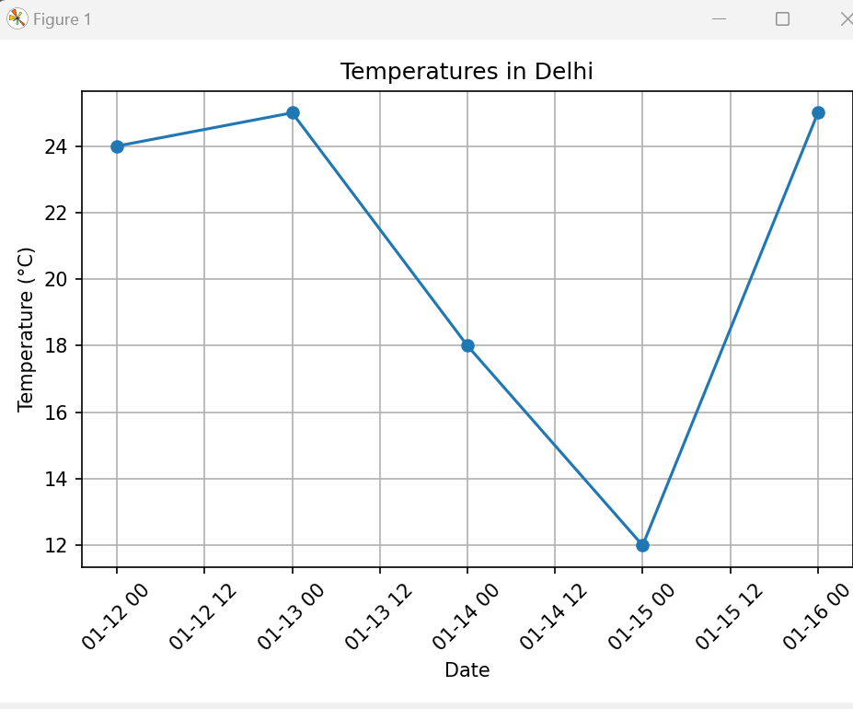

2. City with maximum rainfall

3. City with minimum rainfall In attachment is the data with text files.

[2,3- code](https://github.com/vjk7989/nlp-assignment-11)

**Result –**

Based on the provided weather report, the cities with temperatures less than 25 degrees Celsius are:

1. Shimla (15 degrees Celsius)

2. Guwahati (22 degrees Celsius)

3. Bengaluru (28 degrees Celsius)

Among these cities, Guwahati and Bengaluru have the probability of rain mentioned:

- Guwahati: The report mentions that there's a chance of scattered showers in some areas in the eastern part of India, which includes Guwahati.

- Bengaluru: Although the temperature is below 25 degrees Celsius, there is no explicit mention of rain in the report for Bengaluru. Therefore, we cannot confirm if rain is probable in Bengaluru based solely on this weather report.

So, based on the information provided, Guwahati is the city with a temperature below 25 degrees Celsius and a probability of rain.